Solar Photovoltaic(PV)
• Solar Photovoltaics
A material that can convert the energy in photons of light into an electrical voltage and current is a photovoltaic.
• Solar Insolation
Incoming solar radiation (insolation) is intercepted at the earth's surface as direct, diffuse, and reflected components.
• Tracking systems
Trackers are described as being either two-axis trackers, which track the sun both in azimuth and altitude angles so the collectors are always pointing directly at the sun, or single-axis trackers, which track only one angle or the other.
Solar tracking systems can increase annual power production by 20-40% compared to fixed mounted systems
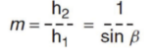
• Air mass ratio (AM)
length of the path taken by sun’s rays through atmosphere to reach a spot on the ground divided by the path length corresponding to the sun directly overhead.

How does a semiconductor material convert sunlight into electricity?
• Energy bands for metals and semiconductors
Band gap energy for silicon is 1.12 eV, i.e. the energy required to jump to conduction band.
• Photon Energy
All the photons in the visible spectrum are strong enough to cause electrons to jump the band gap. Some infrared, all microwave, and all radio waves do not have enough energy and pass right through the solar cell
• Light & the Photovoltaic Effect
Certain semiconductor materials absorb certain wavelengths. The shorter the wavelength, the greater the energy.
Crystalline silicon utilizes all the visible spectrum plus some infrared radiation.
In photovoltaics, the energy source is photons of electromagnetic energy from the sun. When a photon with more than 1.12 eV of energy is absorbed by a solar cell, a single electron may jump to the conduction band. One photon can excite only one electron.
• Band gap impact on Photovoltaic Efficiency
Photons with wavelength < 1.11 µm waste their extra energy. Photons with wavelength > 1.11 µm cannot send electrons to conduction band.
The maximum possible fraction of the sun’s energy that could be collected with a silicon solar cell is 49.6%!
• Important consideration for selection of materials
With smaller bandgap, more photons cross the gap, and high current can be generated but voltage is low.
• Efficiency of PV Cell
Efficiency drops to 49.6% due to losses caused by photons with insufficient or too much energy.
Further drop in efficiency due to:
1. Recombination of holes and electrons before they can contribute to current flow.
2. Only about half to two-thirds of the full band-gap voltage across the terminals of the solar cell.
3. Photons that are not absorbed in the cell
4. Internal resistance within the cell, which dissipates power.
• P-N junction diode
Photovoltaics use p-n junction semiconductor to avoid holes recombining with electrons.
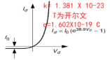
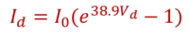

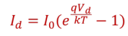

• Equivalent Circuit for a Photovoltaic Cell
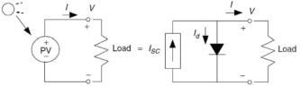
short circuit current is directly proportional to solar insolation.

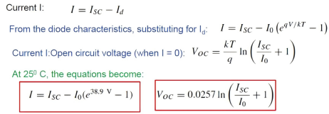

• PV equivalent circuit with an added Rp
The simple equivalent circuit of a string of cells in series suggests no current can flow to the load if any cell is in the dark (shaded). Parallel resistance can deal with this problem.
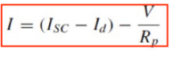
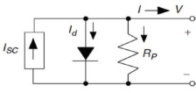

there V=Vd
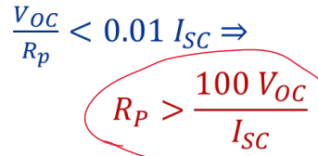
For a cell to have losses of less than 1% due to its parallel resistance:

• Equivalent circuit for PV cell with added Rs
To incorporate other losses, a series resistor is added to the path of current I:
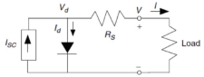

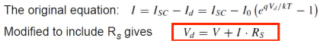

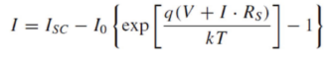


Adding series resistance to the PVequivalent circuit causes the voltage at a given current to shift to the left by ΔV =IR_{S}

• A more accurate equivalent circuit
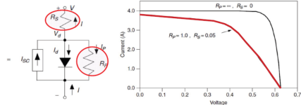

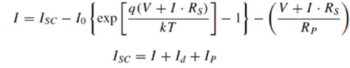

• From cells to a module
Often designated as 12-V module. When wired in series, they carry the same current, but voltages add. Overall module voltage for n cells:
Cells are the building blocks of PV systems. Typically generate 1.5-3 watts of power. Modules or panels are made up of multiple cells. Arrays are made up of multiple modules (panels) that comprises the complete PC generating system.
• From modules to arrays
Modules can be wired in series to increase voltage. Same current flows through all.
Modules can be connected in parallel to increase current, while voltage remains the same.
Series and parallel connection increases power.
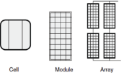

• Maximum Power Point (MPP)
At the maximum power point (MPP), the module delivers the most power that it can under the conditions of sunlight and temperature.
Under load, it is best to maintain operation at this point.
• Current-Voltage Curve for Load
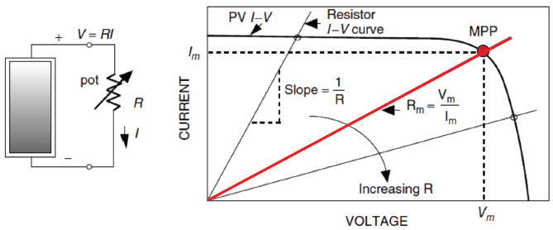
Operating point – intersection of curves where the system will finally operate at.

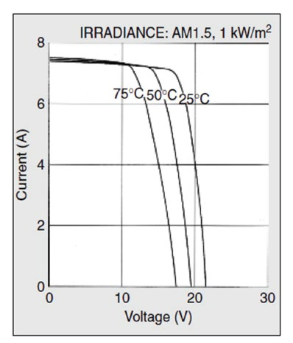
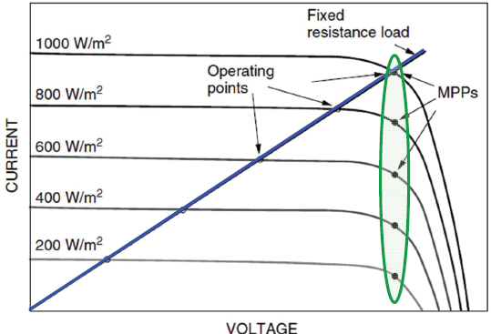
The operating point however, slips off MPP if resistance is fixed. Max power point tracker (MPPT) ensures the module operates at highest efficiency point.

• Effect of temperature
With increase in temperature, voltage reduces while current increases very slightly. For crystalline Silicon
cells, V_{OC} drops by 0.37% per degree C, and I_{SC} increases by 0.05% per degree C. MPP drops by approx 0.5% per degree C.
• Effect of Insolation
As insolation drops, I_{SC} drops proportionately. V_{OC} drops very slightly.
• Effect of Shading
Even if one cell is shaded, since its short circuit current is now zero, the main current I causes the diode to be reserve biased. hence l_{d}=0 and total voltage is reduced by IR_{p}.
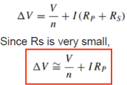
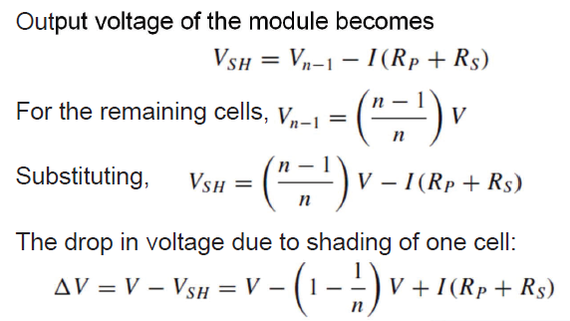

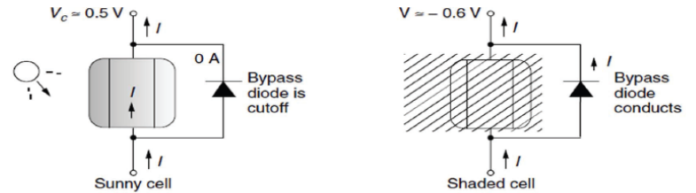
In pratical circuit, Bypass Diode is used to mitigate effect of shading. With bypass diodes, current is diverted around the shaded module.

• Blocking Diodes
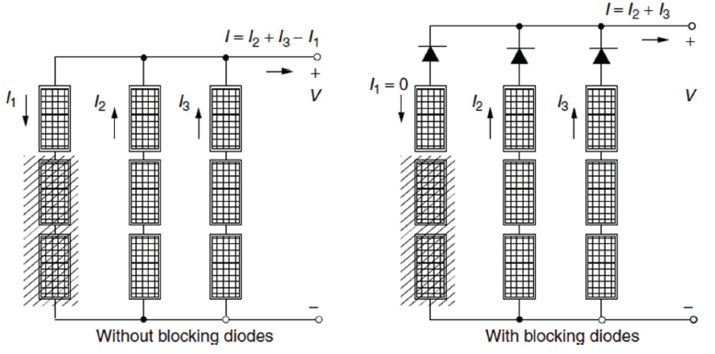
For strings of modules connected in parallel, if one of the strings is not performing well, it tends to draw current. Blocking diodes can prevent the reverse current drawn by shaded string.

Solar PV Systems
• Standard test conditions (STC)
Solar irradiance – 1 kW/m² (sun)
Air mass ratio of 1.5 AM
Cell temperature 25ºC
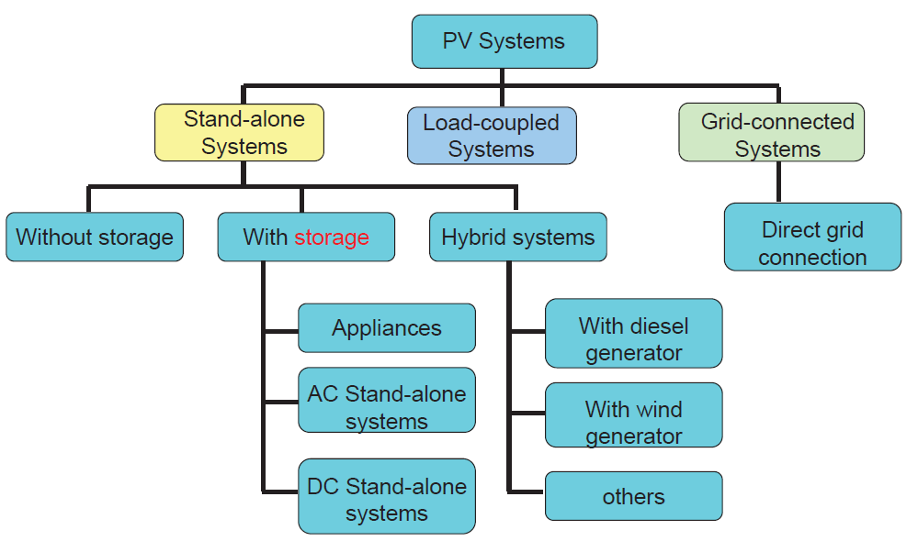
• Types of Solar PV Systems

• Stand-alone DC-only PV System
In simple systems, all loads can be directly run on DC and no inverter may be necessary. Cost-effective in remote locations.
The inverter converts the system's direct-current (DC) electricity to alternating current (AC).
Charge controller regulates the battery charging/discharge.

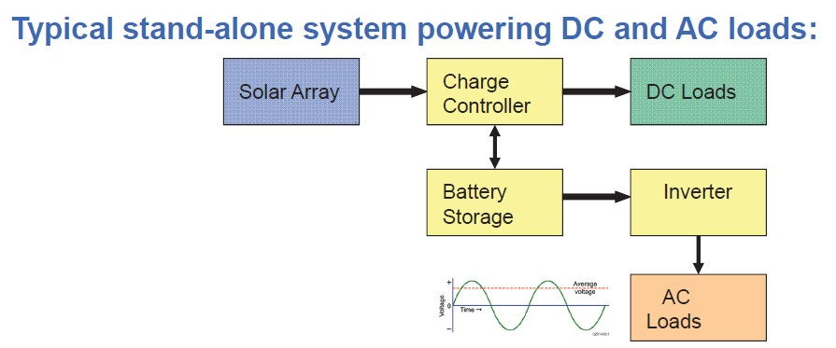

• Load-coupled PV Systems
PV modules are directly connected to their loads. No batteries or power conditioning equipment. Most common – for water pumps. No electric storage (storage in terms of potential energy of water pumped). Very simple and reliable.
A linear current booster (LCB) increases current
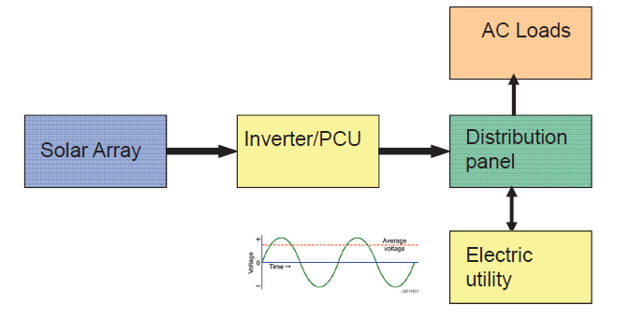
to help start or keep the motor running in low sunlight.
• Grid-connected PV Systems

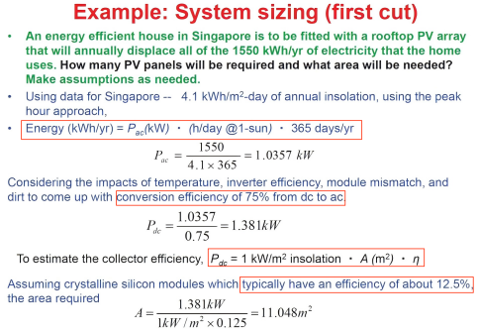

Designed to operate in parallel with, and interconnected, with the electric utility grid.
Components:
(1) The primary component in grid-connected systems is the inverter/PCU which converts the DC power into AC power consistent with the voltage and power quality requirements of the utility grid.
(2) Solar array converts sunlight into electricity.
(3) Charge controller regulates the battery charging/discharge.
(4) The power conditioning unit (PCU) must be designed to quickly and automatically drop the PV system from the grid in the event of utility outage.
(5) A small battery back-up may be included to supply power during such outages.
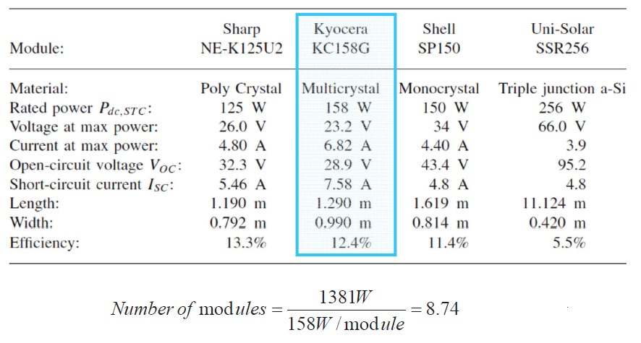
Inverter/PCU automatically stops supplying power to the grid when the utility grid is not energized. Solar power system back-feeds the grid when the solar power system output is greater than the on-site load demand. At night and during other periods when the electrical loads are greater than the solar power system output, the balance of power required by the loads is received from the electric utility. The system requires two meters to keep track of these.
• Maximum Power Point Trackers (MPPT)
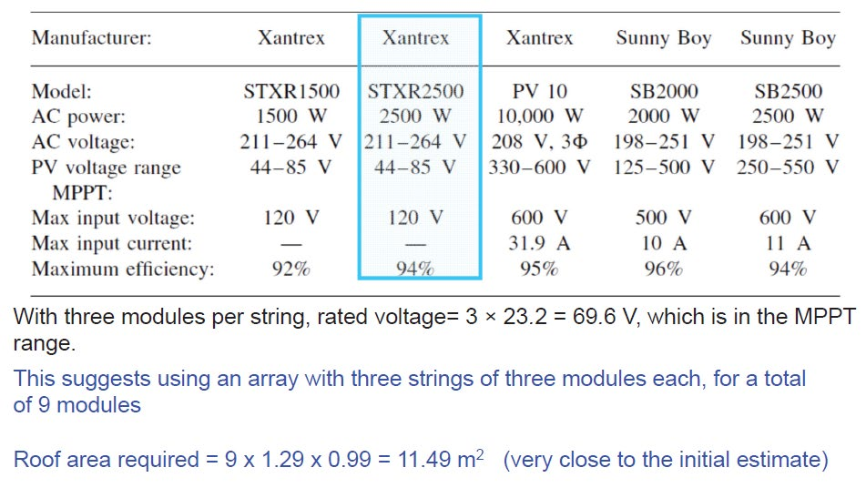
Raises or lowers the voltage to the desired value needed by load.
Buck-Boost Converter circuit
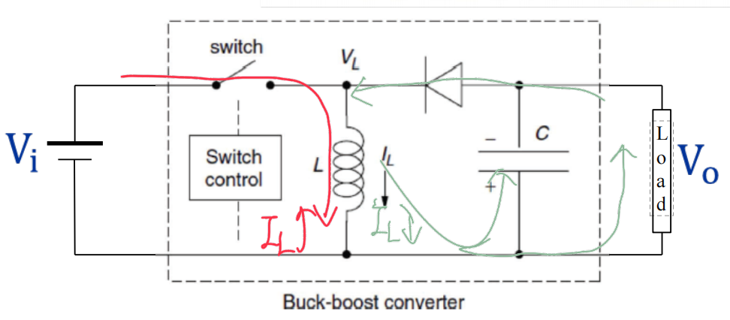
A buck-boost converter is a type of power electronic converter (switch-mode dc-dc converter). Typically, the on-off switch is an IGBT transistor.

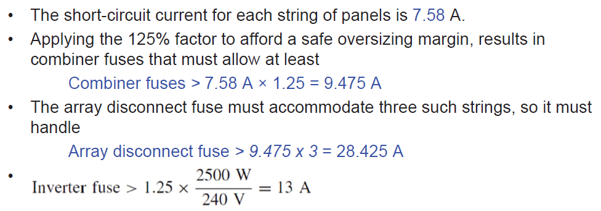
The switch is turned ON and OFF at a frequency of a few tens of kiloHertz. Duty Cycle, or D, is the fraction of time the switch is closed.
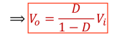
When switch is CLOSED: energy supplied to inductor, and l_{L} builds up. When switch is OPEN: Inductor current flows through C, load, anddiode, and l_{L} decreases. As the change in inductor currentduring two states of the switch, wecan use volt-sec balance of the inductor.

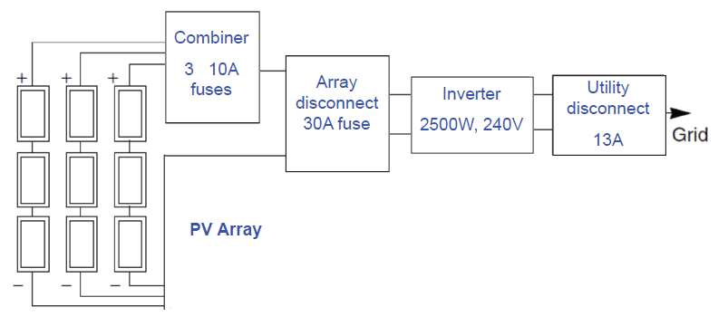
The converter behaves as boost converter when D>0.5. The converter behaves as buck converter when D < 0.5.
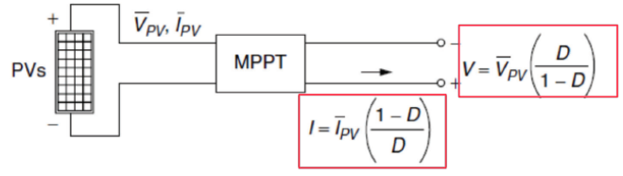

• Different inverter configuration
Large grid-connected systems may use an individual inverter for each string.
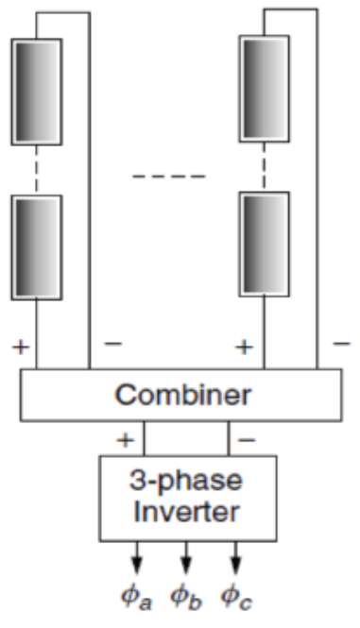
Or, a large central inverter system can be used to provide three-phase power.
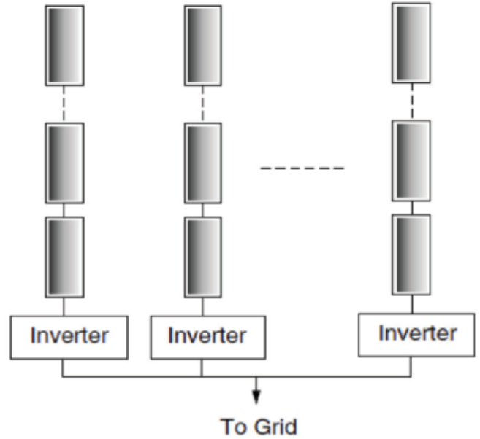

• Interfacing with the utility: Net metering
Whenever PV system delivers more power than demanded by the home, the electric meter runs backwards. When demand > supply from PV, the grid supplies additional power.

Estimating PV System Performance
A good starting point to estimate system performance is ①the rated DC power output of an individual module under standard test conditions (STC). Then we can try to ②estimate the actual AC power output under varying conditions.

The conversion efficiency accounts for inverter efficiency, dirty collectors, mismatched modules, and differences in ambient conditions. Even in full sun, the impact of these losses can easily derate the power output by 20-40%.
• Efficiency of the inverter
Efficiency of the inverter depends on the load. Typical grid-connect inverters have efficiencies above 90% for upto 20% loading.
• Effect of temperature
With increase in temperature, voltage reduces while current increases very slightly. MPP, or rated DC output power drops by approx 0.5% per degree C.
The
• ‘‘Peak- Hours’’ Approach
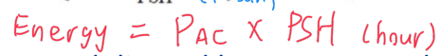
If we know the AC power delivered by an array under 1-sun insolation (PAC), we can just multiply that rated power by the number of hours of peak sun to get daily kWh delivered (energy delivered in a day). (估算PV一天传输能量)
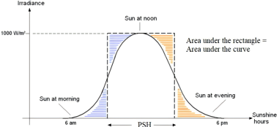

• Capacity Factors (CF) for PV Grid-Connected Systems
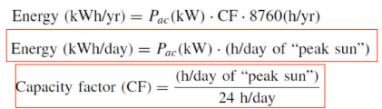
If the system delivered full, rated power continuously, the capacity factor (CF) would be unity.

• Grid-connected PV system design
估算光伏阵列的额定功率和所需面积。探究光伏组件和逆变器的选择之间的相互作用，以及如何选择光伏阵列的布局。最后，考虑熔断器、开关和导体的电压和电流额定值的细节。
System sizing:

Number of modules required:

• Technical issues for system integration of PV
Long term planning:
(1)Pros: modular, low emissions, small footprint
(2)Cons: non-dispatchable, requires different planning frameworks
Short term operations:
(1)Do not fit into the existing or emerging institutional structures (system operation, market rules)
• Cost-Effectiveness of Installation
(1) Tracking arrays of modules gather more energy (perhaps 35%) but add to the cost; one could just increase array area in a fixed mount.
(2) Reduce load demand by conserving energy and efficiency – the rule is that saving a watt in conservation is worth saving three watts in conversion.
(3) Compare installation & utility line extension costs.
(4) Consider adding wind turbine for hybrid energy.
(5) Use fueled generator occasionally to decrease cost of PV.
(6) Modules can be placed vertically on the side of a building at high latitudes or flat on the roof at low latitudes.

Q.1Explain how crystalline Silicon converts sunlight into electricity in PV cells.
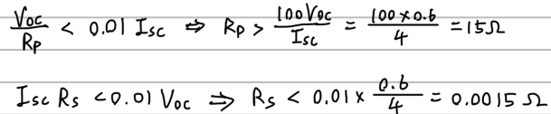
Band gap energy for silicon is 1.12 eV, i.e. the energy required to jump to conduction band.In photovoltaics, the energy source is photons of electromagnetic energy from the sun. When a photon with more than 1.12 eV of energy is absorbed by a solar cell, a single electron may jump to the conduction band. Electricity is generated through the jumping. One photon can excite only one electron

Q.2What is the theoretical maximum conversion efficiency of Silicon based solar PV cells?Explain the reason behind this.
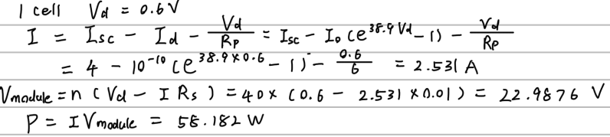
The maximum possible fraction of the sun’s energy that could be collected with a silicon solar cell is 49.6%. Photons with wavelength < 1.11 µm waste their extra energy with percentage of 30.2%. Photons with wavelength > 1.11 µm cannot send electrons to conduction band with the percentage of 20.2%

Q.3What are the various losses in PV cells which reduce the conversion efficiency below the theoretical maximum efficiency?
Efficiency drops to 49.6% due to losses caused by photons with insufficient or too much energy.
Further drop in efficiency due to:
1. Recombination of holes and electrons before they can contribute to current flow.
2. Only about half to two-thirds of the full band-gap voltage across the terminals of the solar cell.
3. Photons that are not absorbed in the cell
4. Internal resistance within the cell, which dissipates power.

Q.4 Draw the complete equivalent circuit of the solar PV cell. Explain the principle behind each
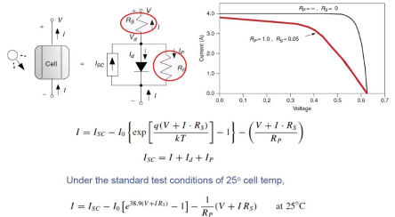
component in the equivalent circuit.

I_{sc}:Current source Diode:PV use p-n junction semiconductor to avoid holes recombining with electrons. Rp:Allow current to flow to the load if any cell is shaded. Rs:In corporate other losses

Q.5 Find the open circuit voltage of solar PV cell with the following information given. Ambient temperature 40ºC. Boltzmann constant k= 1.381x10⁻²³,charge of electron q=1.602X10⁻¹⁹C. Short circuit current is 4A and the reverse saturation current is 10⁻¹⁰A.

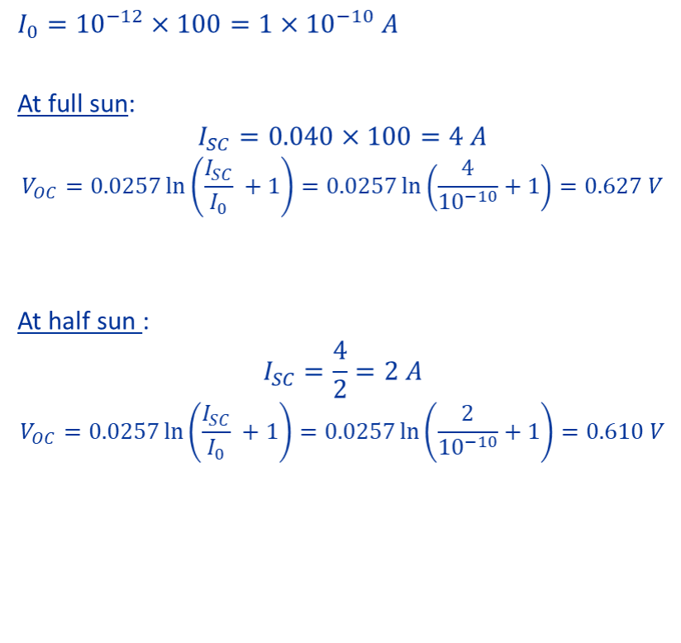
Ex1:Consider a 100-cm² photovoltaic cell with reverse saturation current I₀=10⁻¹²A/cm2.In full sun, it produces a short-circuit current lsc=40 mA/cm²at25°C. Find the open-circuit voltage at full sun and again for 50% sunlight. Plot the results.

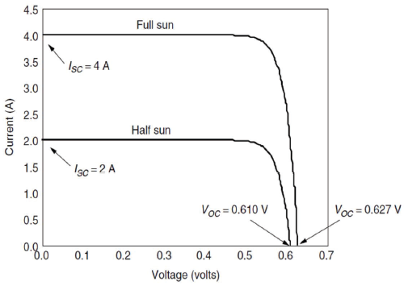

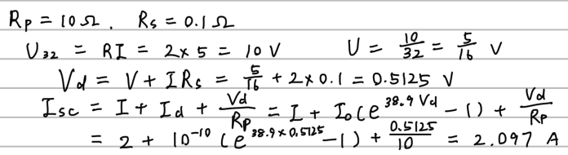
Q.6 A solar PV module with 32 cells in series supplies 2A to a 5Ω load. The ambient temperature is25ºC. The parallel and series resistors in the PV cell equivalent circuit are 10Ω and 0.1Ω respectively. The reverse saturation current of the junction is 10⁻¹⁰A. Determine the short circuit current of the cell.
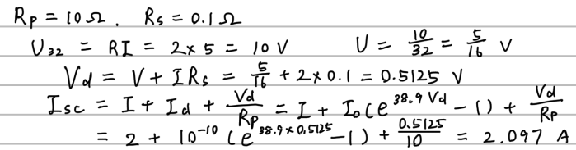

Q.7 The loss due to series and parallel resistors in the equivalent circuit of the PV cell are less than 1 percent. Determine the limits of their values if the Voc=0.6V and Isc =4A.

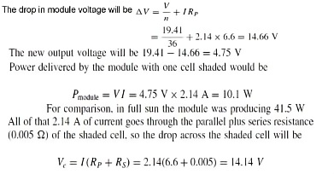

Q.8 A PV module is made up of 40 identical cells, all wired in series.With 1-sun insolation (1kW/m²), each cell has short-circuit current Isc = 4A and at 25ºC its reverse saturation current is I₀=10⁻¹⁰A. Parallel resistance Rp = 6Ω and series resistance Rs =0.01Ω.Find the voltage, current, and power delivered when the junction voltage of each cell is 0.60V.

Ex2:A PV module is made up of 36 identical cells, all wired in series. With 1-sun insolation (1 kW/m²), each cell has short-circuit current ISC = 3.4A and at 25oC its reverse saturation current is I₀= 6×10⁻¹⁰A. Parallel resistance Rp = 6.6Ω and series resistance Rs = 0.005 Ω. Find the voltage, current, and power delivered when the junction voltage of each cell is 0.50 V.
A typical module has 36 cells and often designated at 12V module.
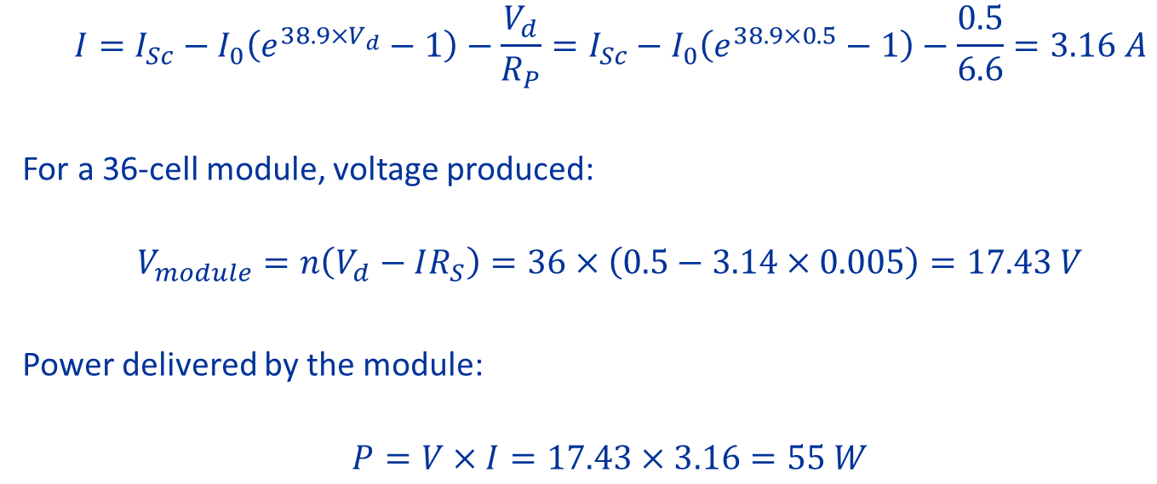

Q.9 A PV cell output can be approximated to be linear from the maximum power point till the
open circuit voltage. MPP voltage and current are: Vp = 0.5V and Ip = 4A. The open circuit voltage Voc = 0.6 V. Determine operating point if a 1 Ω resistor is connected to the PV cell.
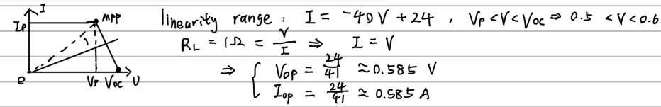

Q.10 What constitute standard test conditions (STC) for solar PV cells?
•Solar irradiance –1 kW/m²(sun)
•Air mass ratio of 1.5AM
•Cell temperature 25ºC

Q.11 How does solar insolation affect the short circuit current and open circuit voltage of the solar PV cells?
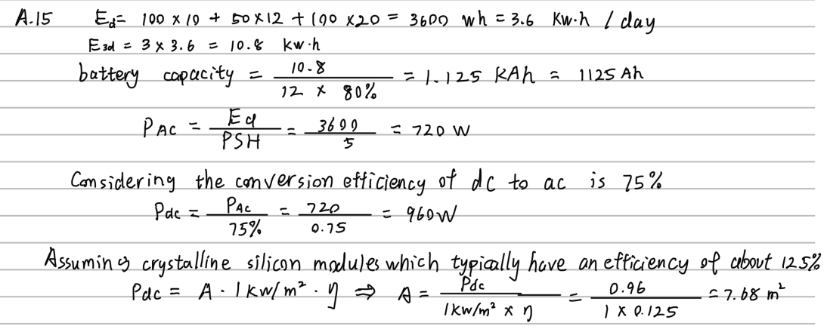
Effect of Insolation
• As insolation drops, ISC drops proportionately
• VOC drops very slightly

Q.12 effect of partial shading
Explain the effect of partial shading in solar PV modules? How is the effect mitigated in practical circuits?
Even if one cell is shaded, since its short circuit current is now zero, the main current I causes the diode to be reserve biased, hence Id=0 and total voltage is reduced by Irp
Ex. Effect of energy storage
•Variations in power generating capacity –temporal fluctuations are large on a daily and seasonal basis
• Without energy storage, solar power will only be available when the sun is shining
• Storage allows optimal operation and utilization of energy

Q.13 Shading 阴影遮盖变化
A 40-cell PV module has a parallel resistance per cell of RP =5 Ω where as the series resistance is Rs=0.01Ω . In full sun and at current I = 3 A the output voltage was found there to be V = 24V. If one cell is shaded and the current somehow stays the same, then: P51
a. What would be the new module output voltage and power?
b. What would be the voltage drop across the shaded cell?
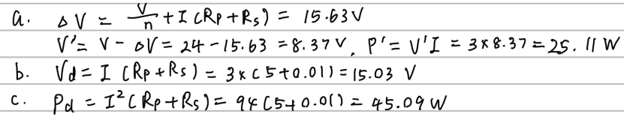
c. How much power would be dissipated in the shaded cell?

Ex3: The 36-cell PV module described in previous example had a parallel resistance per cell of RP = 6.6 Ω. In full sun and at current I = 2.14 A the output voltage was found to be V =19.41V. If one cell is shaded and this current somehow stays the same,
a) What would be the new module output voltage and power?
b) What would be the voltage drop across the shaded cell

Ex. Types of Solar PV Systems

Q.14 a stand-alone Solar PV system
Using block diagram show the components of a stand-alone Solar PV system for a remote home. Describe the function of various components.

•Solar array converts sunlight into electricity
•The inverter converts the system's direct-current (DC) electricity to alternating current (AC)
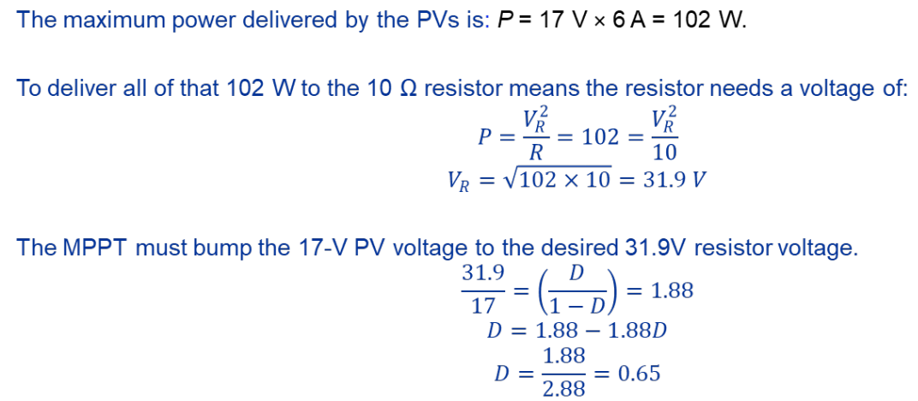
•Charge controller regulates the battery charging/discharge
•Storage allows optimal operation and utilization of energy

Q.15 The area needed
A remote home uses following appliances daily. Design the size of the solar PV panel and the battery capacity in Ah if the 12V battery is supposed to store energy for about 3 days. Assume that the battery can be discharged up to 80% of its storage capacity. The location has 5 peak-sun hours on an average. Assume full-sun insolation is 1kW/m2.

Q.16 losses in output power
What are the various causes for the losses in output power in a PV system?
•Variations in power generating capacity –temporal fluctuations are large on a daily and seasonal basis
• Without energy storage, solar power will only be available when the sun is shining
Ex. What is Load-coupled PV Systems
•PV modules are directly connected to their loads
• No batteries or power conditioning equipment
• Most common – for water pumps
• No electric storage (storage in terms of potential energy of water pumped)
• Very simple and reliable

Q.17 grid-connected solar PV system并网系统
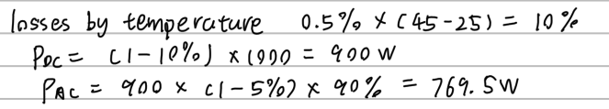
Using detailed block diagram, show the components of a grid-connected solar PV system. Describe the function of each component.

•Photovoltaics (solar array) capture light and generate electricity.
•Inverter/PCU(power conditioning unit) converts the DC power into AC power consistent with the voltage and power quality requirements of the utility grid.
•Distribution panel controls that Solar power system back-feeds the grid when the solar power system output is greater than the on-site load demand.
•At night and during other periods when the electrical loads are greater than the solar power system output, the balance of power required by the loads is received from the electric utility.

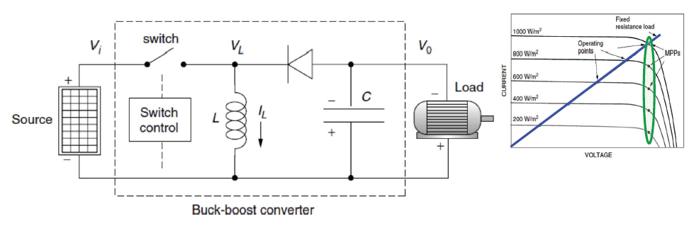
Q.18 Describe the operation of buck-boost converter used for MPPT operation in solar PV system.

• When switch is CLOSED: energy supplied to inductor, and IL builds up
• When switch is OPEN: Inductor current flows through C, load, and diode, and IL decreases
• As the change in inductor current during two states of the switch, we can use volt-sec balance of the
The converter behaves as boost converter when D > 0.5.
The converter behaves as buck converter when D < 0.5.
Ex. What is Maximum Power Point Trackers (MPPT)
• Standard part of most grid-connected systems
• Commonly use a buck-boost converter (also used in linear current boosters)
• Raises or lowers the voltage to the desired value needed by load
Ex4. Under certain ambient conditions, a PV module has its maximum power point at Vm = 17V and Im = 6A.What duty cycle should an MPPT have if the module is delivering power to a 10Ω resistance?

Q.19 Duti cycle of MPPT 求占空比
Under certain ambient conditions, a PV module has its maximum power point at V_{m} = 16 V and I_{m} = 4A. What duty cycle should an MPPT buck-boost converter have if the module is delivering the same power to a 1Ω resistance?

Ex5. Consider a PV array rated at 1 kW under standard test conditions. Module cell temperature is 53.8ºC. DC power output at the MPP drops by 0.5%/ºC above the STC temperature of 25ºC. Estimate its ac output if there is a 3% array loss due to mismatched modules, dirt loss is 4%, and the inverter has an efficiency of 90%.
With power loss at 0.5% per degree above 25ºC, the DC rated power of the array would be:
P_{DC} = 1kW[1 - 0.005(53.8 - 25)] = 0.856 kW
Including mismatch, dirt, and inverter efficiencies will result in an estimated AC rated power:
P_{AC} = 0.856kW × 0.97 × 0.96 × 0.90 = 0.72kW

Q.20 Condition on efficiency (Temperature)
A PV panel under standard test conditions produces an output of 1000W. The output drops by 0.5%/C due to temperature rise and 5% due to dirt accumulation on it. The ambient temperature is 450C. Assuming power converter efficiency of 90%, determine the expected maximum AC power output from the panel.

